PRACTICAL 2: CREATING ACCOUNT, REPOSITORY ON GITHUB AND CLONING REPOSITORY IN GITHUB

A) CREATING ACCOUNT

1 )GO TO [GITHUB.COM](https://github.com/) IN YOUR BROWSER AND CLICK ON SIGN UP ON THE TOP LEFT CORNER



2) FILL IN THE DETAILS & THEN CLICK CREATE ACCOUNT

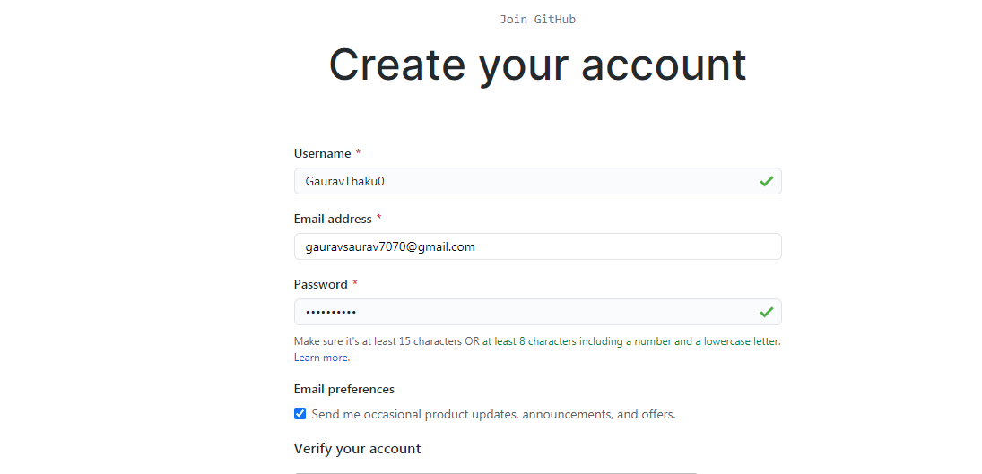

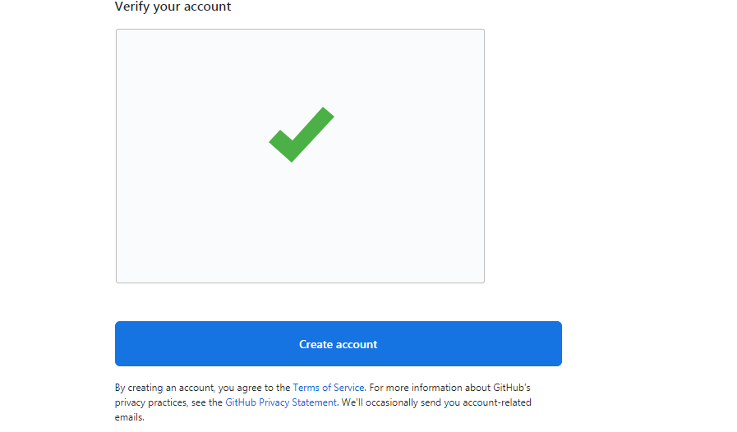

3) CLICK THE BOXES AS PER YOUR CIRCUMSTANCES & CLICK ON COMPLETE SETUP



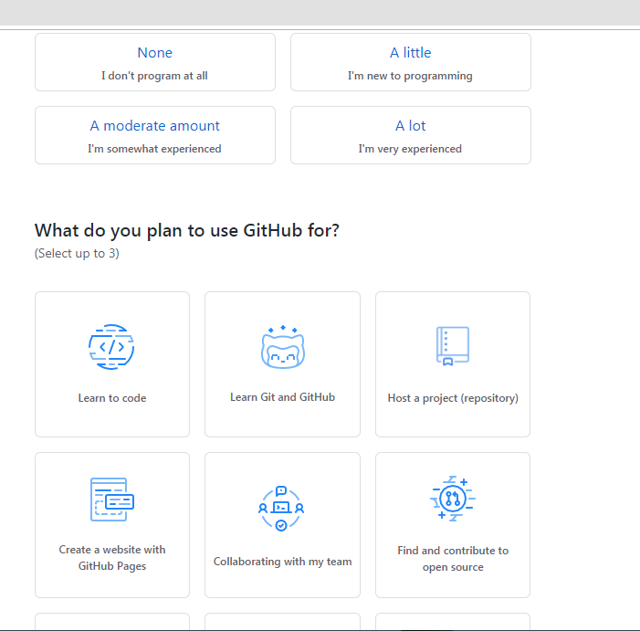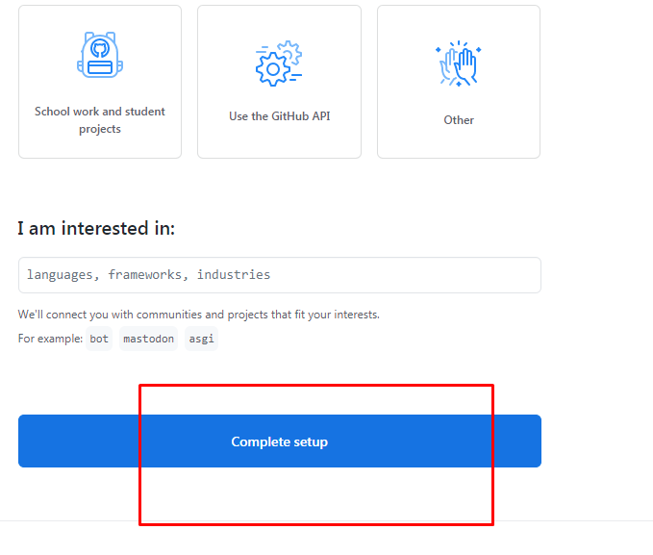

4)THIS PAGE WILL APPEAR THEN CHECK YOUR GMAIL FOR A GITHUB EMAIL

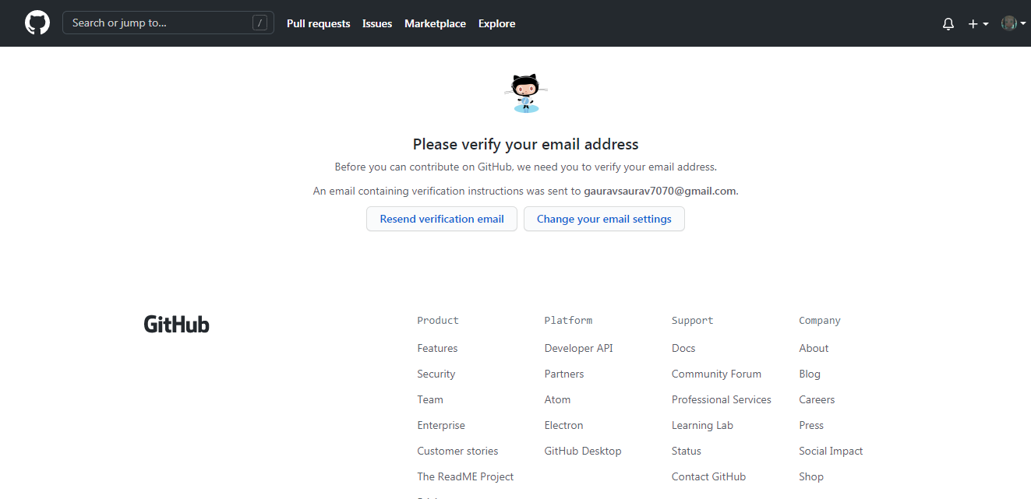

5) CHECK FOR THE GITHUB EMAIL ON YOUR GMAIL ON THE EMAIL ID YOU ENTERED IN 2ND STEP AND CLICK ON IT & CLICK ON VERIFY EMAIL ADDRESS

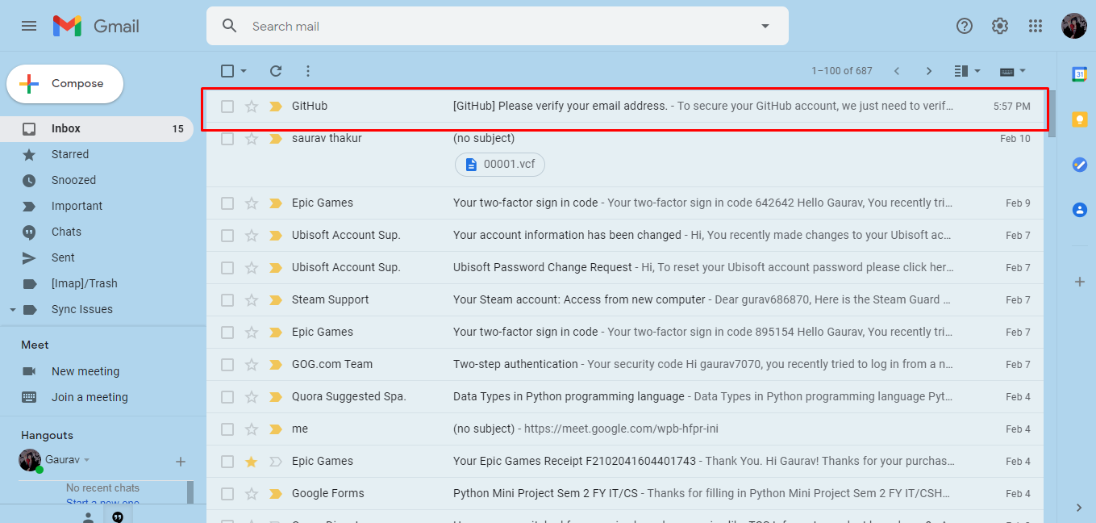

6) after verifying this page you will redirected to this page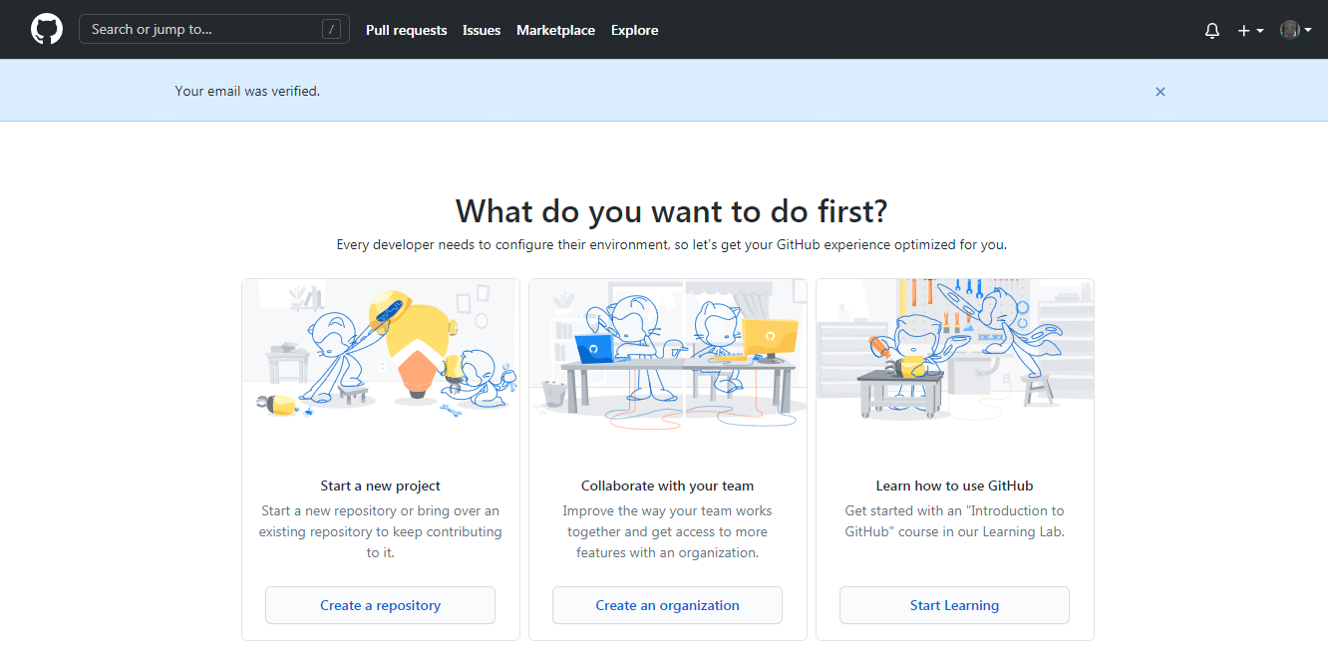

B) CREATING REPOSITORY

1) IF IT’S YOUR FIRST TIME CREATING A REPOSITORY CLICK ON CREATE REPOSITORY

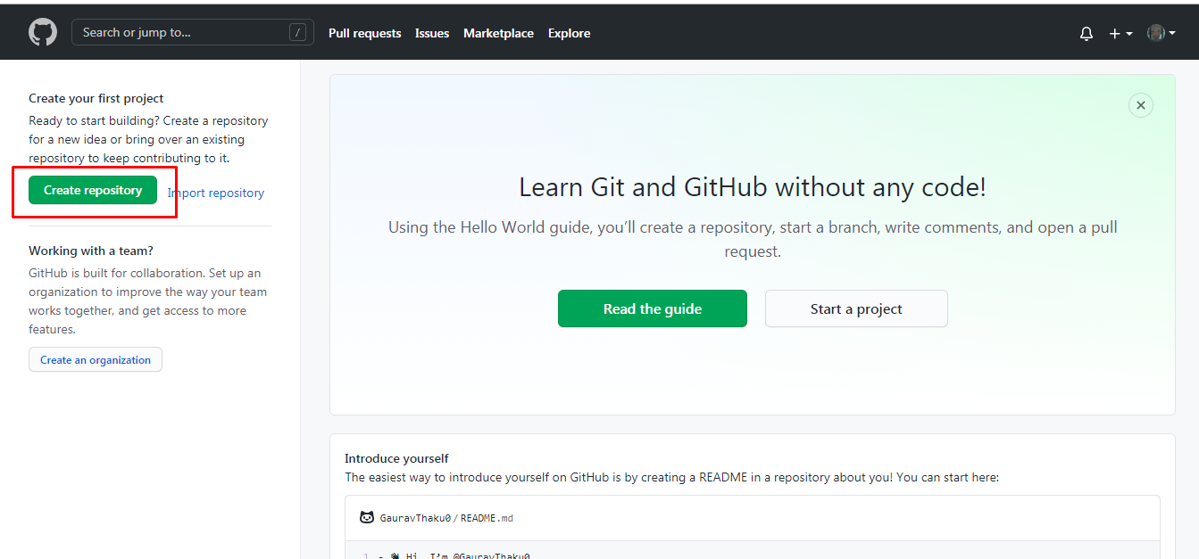

2) FILL IN THE REPOSITORY NAME, KEEP IT PUBLIC OR PRIVATE AS PER YOUR NEED

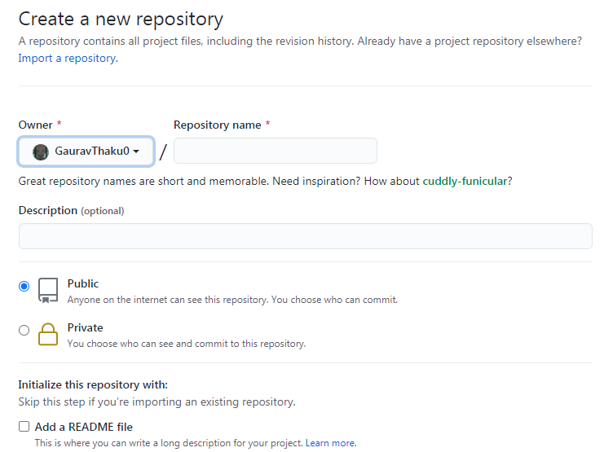

3)CLICK ON ADD A README FILE AND CLICK CREATE REPOSITORY

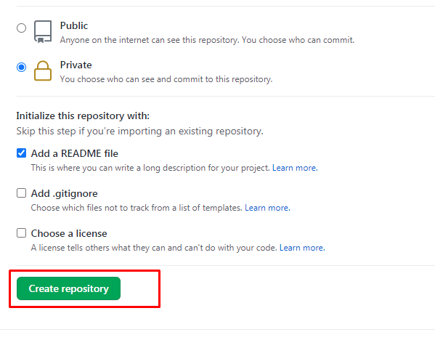

4) NOW YOUR REPOSITORY HAS BEEN CREATED

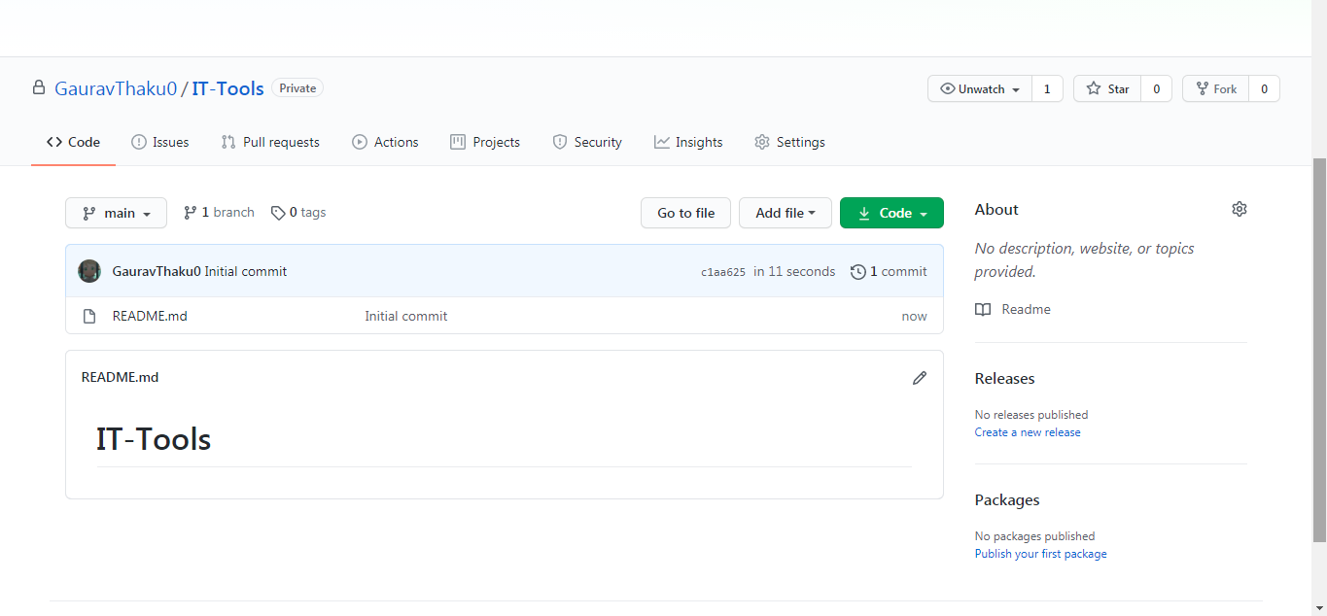

C) CLONING REPOSITORY

1)GO TO [GITHUB.COM](https://github.com/) AND CLICK ON YOUR REPOSITORY

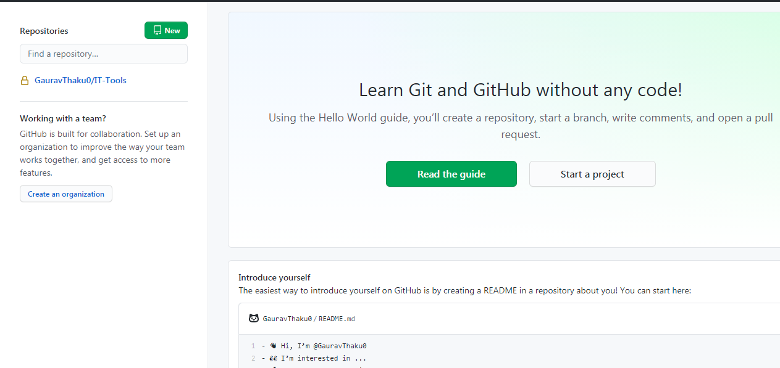

2) CLICK CODE AND THEN CLICK THE SMALL ICON THAT IS BESIDES THE LINK

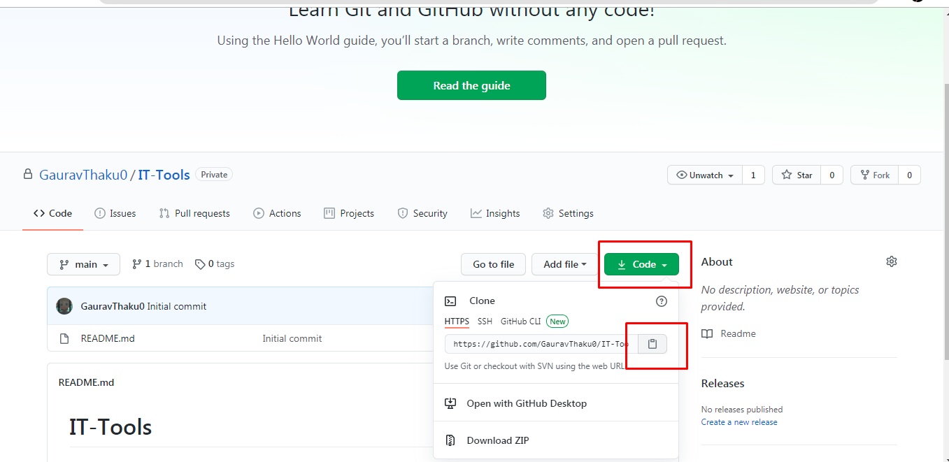

3) NOW YOUR REPOSITORY IS CLONED (I.E. YOUR REPOSITORY LINK IS COPIED)